Number 1 – Brightside & REXX Demo

* This Demo has been developed as a sample of how Brightside can be used with REXX as the language for scripting.
* There is a REXX program REXXN1 that gives us Song and Artist #1 in UK at a certain date. The program needs a parameter in the format ‘aaaammdd’.
* As any other REXX program, one way to execute it could be from any command line:

===> TSO EX '<tsoid>.N1.PROD.REXX(REXXN1)' '19650422'

-------------------------------

On 1965/04/23 #1 in UK was:

-------------------------------

UK_Title : TICKET TO RIDE

UK_Artist: BEATLES

* The goal is to have a Jenkins Pipeline defined in order to be able to modify the application, run tests and if everything goes ok, install in production.
* Application structure:

TEST

PROD

<tsoid>.N1.TEST.REXX

UK #1 List

<tsoid>.N1.PROD.REXX

z/OS



<tsoid>.N1UK.MASTER

* All code is in GitHub: ‘https://github.com/drb1972/Number1_Share.git’. The repository is not public, so you need to ask me to share it with your GitHub user.
* **ooRexx** in needed to execute the scripts. Open Object REXX will be used as the scripting language instead JavaScript. It is free and can be downloaded for several operating systems. Can be downloaded from <https://sourceforge.net/projects/oorexx/files/oorexx/4.2.0/>
* Since Jenkins is not going to execute the scripts in our user profile, it is necessary to have already installed the necessary resources:
  + In the system variables it is necessary to add: C:\Program Files\ooRexx to the PATH. Brightside needs be in the system path too (not the user profile path).
  + Bright zosmf-profile and tso-profile need to be defined at system level, not the user one. Check your password is the current one or it will be revoked for several logon tries.
* **Important:** Edit “start.rexx” and write your TSOID in “**TSOID=’xxxxxxxx’**”. The purpose of this is because the sample will be created under you tso userid HLQ.
* **‘Start.rexx’** is the task runner, and it has several steps, but only one at a time will be executed (same as Gulp). These steps are:

1. ALLOC: if the library structure doesn’t exists, it is created.
   1. <tsoid>.N1.TEST.REXX
   2. <tsoid>.N1UK.MASTER
2. UPLOAD:
   1. **Rexxn1.rex** is uploaded to PDS: <tsoid>.N1.TEST.REXX(REXXN1)
   2. **listUKMaster.txt** is uploaded to PS: <tsoid>.N1UK.MASTER.
3. TESTT_UK: A couple of test are done to keep within the Pipeline. If any test does not end as expected, Jenkins will stop the Pipeline.
4. INSTALL:
   1. If <tsoid>.N1.PROD.REXX doesn’t exists. It is created.
   2. If <tsoid>.N1.PROD.REXX.BACKUP doesn’t exists. It is created.
   3. Copy REXXN from <tsoid>.N1.PROD.REXX to <tsoid>.N1.PROD.REXX.BACKUP (not in the first Install).
   4. Copy REXXN from <tsoid>.N1.TEST.REXX to <tsoid>.N1.PROD.REXX
5. TESTP_UK: A couple of test are done. If test does not end as expected, an automatic BackOut is executed to restore the last REXXN1 version (not the first time).

* **GitHub:**

To share the code with you:

1. I need your GitHub user in order to add you as a Collaborator. You will receive an invitation to join Number1_Share repository.
2. 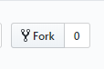Once you can see <my-user>/Number1_Share in your GitHub you have to “FORK” it by clicking here:
3. Once is forked, you will have your own repository to test the ‘Number1’ application and Pipeline as: <your-GitHub-User>/Number1_Share
4. Clone it in your projects folder from the CLI:

git clone ‘https:// <your-GitHub-User>/Number1_Share’

* **Jenkins:**

1. New item:

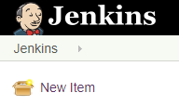

1. Enter a Name (I named Number1), select Multibranch Pipeline and click on the ‘ok’ button.

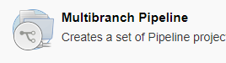

1. Select GitHub in the ‘Add source’ drop down menu and paste your user GitHub url:
   1. [https://github.com/<your-github-user>/Number1_Share.git](https://github.com/%3cyour-github-user%3e/Number1_Share.git). Description is optional. Click on the ‘Save’ button.

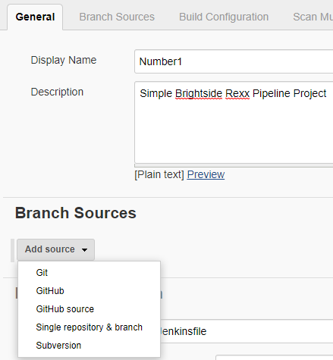

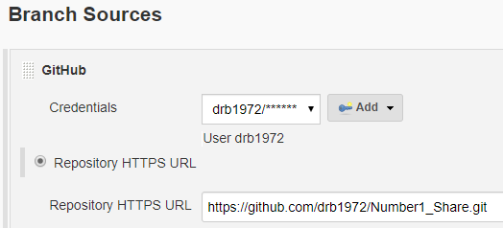

* 1. Validate the credentials to have access. (At this moment the Number1_Share GitHub repository is private, and as far as I know if I make it public, anyone could push changes. I haven’t figured out yet how to share it ‘Read only’).
  2. Save.

1. Jenkins will check now the branches and run the Build Executor.
   1. You can click on Number1 >> master and you will see the first run of the project

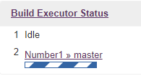

1. In the main page, select Number1 project:

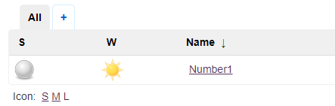

1. Select ‘Build now’:



* Hopefully you will succeed in the Pipeline process:

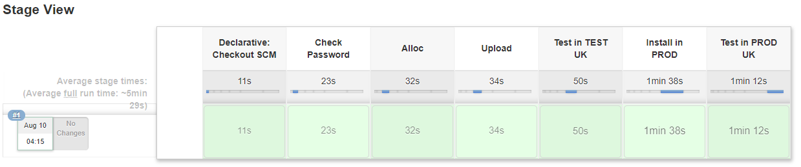

* 1. These are the standard outputs you can see in the Jenkins Pipeline steps log:
     1. Step - Check Password: This output should be always the same. I begin with this step because if my password has expired and If I issue 3 Brightside commands against the mainframe, my password will be revoked. I has happened to me already ☺

+ rexx start pass

Correct TSO access.

* + 1. Step – Alloc

+ rexx start alloc

========================================

>> ALLOC - Create libraries

========================================

Creating RODDI01.N1.TEST.REXX

Data set created successfully.

Creating RODDI01.N1UK.MASTER

Data set created successfully.

First execution:

Subsequent executions:

+ rexx start alloc

========================================

>> ALLOC - Create libraries

========================================

RODDI01.N1.TEST.REXX Already exists

RODDI01.N1UK.MASTER Already exist

* + 1. Step – Upload: This output should be always the same.

+ rexx start upload

========================================

>> UPLOAD - Upload libraries

========================================

Uploading RODDI01.N1.TEST.REXX

Uploading RODDI01.N1UK.MASTER

* + 1. Step – Test in TEST UK: This output should be always the same.

+ rexx start testt_uk

========================================

>> TESTT_UK - TESTING in TEST

========================================

========================================

Beginning Test1...

========================================

Expected result for 19600826:

UK_Title : APACHE

UK_Artist: SHADOWS

========================================

Result ==> UK_Title : APACHE

Result ==> UK_Artist: SHADOWS

TEST1 OK

========================================

Beginning Test2...

========================================

Expected result for 18600826:

NULL value

========================================

NULL value

TEST2 OK

Tests in TEST OK

* + 1. Step – Install in PROD:

First execution:

+ rexx start install========================================

>> INSTALL - Install in PROD

========================================

Creating RODDI01.N1.PROD.REXX

Data set created successfully.

Creating RODDI01.N1.PROD.REXX.BACKUP

Data set created successfully.

Copying REXXN1 from RODDI01.N1.TEST.REXX to RODDI01.N1.PROD.REXX

Successful Install

Subsequent executions:

+ rexx start install========================================

>> INSTALL - Install in PROD

========================================

RODDI01.N1.PROD.REXX Already exists

RODDI01.N1.PROD.REXX.BACKUP Already exists

Copying REXXN1 from RODDI01.N1.PROD.REXX to RODDI01.N1.PROD.REXX.BACKUP

Successful BackUp

Copying REXXN1 from RODDI01.N1.TEST.REXX to RODDI01.N1.PROD.REXX

Successful Install

* + 1. Step – Test in PROD UK: This output should be always the same.

+ rexx start testp_uk

========================================

>> TESTP_UK - TESTING in PROD

========================================

========================================

Beginning Test1...

========================================

Expected result for 19600826:

UK_Title : APACHE

UK_Artist: SHADOWS

========================================

Result ==> UK_Title : APACHE

Result ==> UK_Artist: SHADOWS

TEST1 OK

========================================

Beginning Test2...

========================================

Expected result for 18600826:

NULL value

========================================

NULL value

TEST2 OK

========================================

Tests in PROD OK

* After the first installation in PROD, you can execute REXXN1. Just type ‘rexx testn1’ in the CLI and you will be prompted for a date. But before executing it, edit the script testn1.rex and set your tsoid in user = 'xxxxxxxx'.
* In the same way as Gulp, you can execute in the CLI one of the stages of the Pipeline by executing ‘rexx start <step>’. You can see the name of the steps in the Jenkinsfile right behind each description.
* It is also possible to define Gulp tasks in combination with the REXX scripts. This gives us the flexibility of choosing the most suitable for each purpose.

* This Demo has been created also to share ideas that could be extrapolated to any project. For example: It is included a simple REXX script called ‘**commit_n1.rex’** that easy and group some commands. When executed:

1. Automatically edits the rexxn1.rex program and sets the timestamp when it is uploaded to GitHub, therefore we can always see when was the source code sent to compile, or whatever: The code is updated with the following format at the top of the program:

/* timestamp - 2019-08-10T05:15:34.232000 */

1. Sets the GitHub configuration to the GitHub user I am using with this repository. I do this because I have more than 1 GitHub account linked with different projects.
2. Commit the files that have been changed
3. PUSH into your default GitHub repository

To execute it: ‘rexx commit_n1’ in the project folder.

(I have some utilities like this in a folder added to the path of my windows system, so I can execute any in all projects just as command lines. In mainframe it would be scripts in my logon SYSPROC library).

* Practice 1: Let’s make the tests in TEST fail. Jenkins should stop the execution of the Pipeline and not allow the program go into production PROD. To do that we will do the following:

1. Edit the ‘listUKMaster.txt’ file in the Workspace and change line #15. This line is the one used in our test script, expecting ‘APACHE’. We will modify it to ‘APACH ’:

25/08/1960;APACHE;SHADOWS;5 -> 25/08/1960;APACH ;SHADOWS;5

1. Execute in the CLI: ‘rexx commit_n1’

1. In Jenkins start a Build. It should fail in the step ‘Test in TEST UK’ and stop the installation:

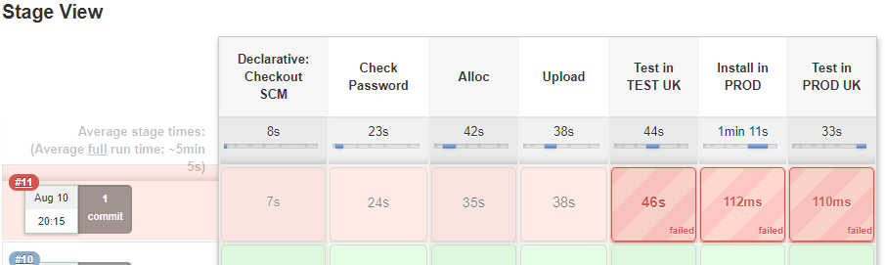

Taking a look at the ‘Test in TEST UK’ log:

+ rexx start testt_uk========================================

>> TESTT_UK - TESTING in TEST

========================================

========================================

Beginning Test1...

========================================

Expected result for 19600826:

UK_Title : APACHE

UK_Artist: SHADOWS

========================================

Result ==> UK_Title : APACH

Result ==> UK_Artist: SHADOWS

**TEST1 KO**

========================================

Beginning Test2...

========================================

Expected result for 18600826:

NULL value

========================================

NULL value

TEST2 OK

Tests in TEST **not OK**

1. Now we will edit again the listUKMaster.txt and will restore the ‘E’ in APACHE in line 15.

* Practice 2: Now we are going to make the program fail after it has passed the tests in TEST and have been installed in production PROD. The script executes a couple of tests right after the program has been installed and if any fails, there is a BackOut procedure that will restore the latest version of the program that was running in production. To provoke this situation we are going to modify the testing script in production:

1. Take a look at the timestamp in the current production program REXXN1 in the mainframe: <tsoid>.N1.PROD.REXX(REXXN1). Mine shows 05:15:34. (I woke up early!!!).

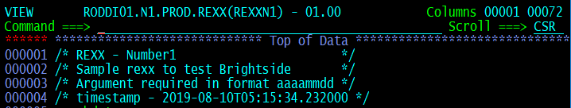

1. Edit the **start.rex** script, find the following paragraph and modify it uncommenting the code:

Before:

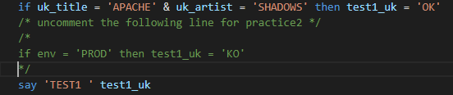

After:

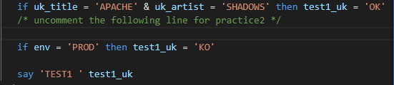

1. Execute ‘**rexx commit_n1’**. This will update in GitHub the script and the program **rexxn1.rex** with the new timestamp. After issuing the command, you can access to the source code in GitHub to check the new timestamp (21:05:18):

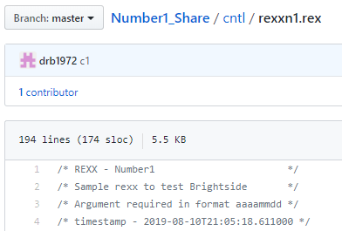

1. In Jenkins, Build now. The Pipeline should fail in the last step ‘Test in PROD UK’ and restore the last version in Production just replaced in the ‘Install in PROD’ step.

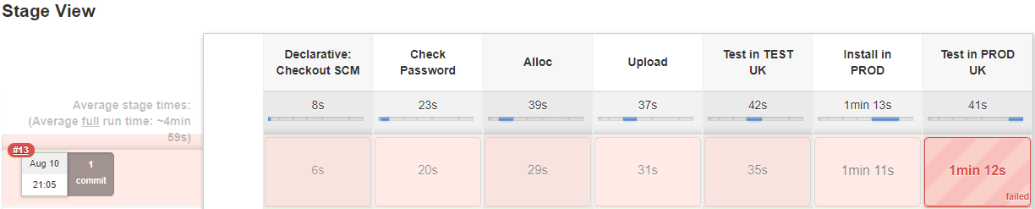

The log for the ‘Test in PROD UK’ Shows:

+ rexx start testp_uk========================================

>> TESTP_UK - TESTING in PROD

========================================

========================================

Beginning Test1...

========================================

Expected result for 19600826:

UK_Title : APACHE

UK_Artist: SHADOWS

========================================

Result ==> UK_Title : APACHE

Result ==> UK_Artist: SHADOWS

TEST1 KO

========================================

Beginning Test2...

========================================

Expected result for 18600826:

NULL value

========================================

NULL value

TEST2 OK

========================================

**Tests in PROD not OK**

**Launching BACKOUT to restore PROD library**

Copying REXXN1 from **RODDI01.N1.PROD.REXX.BACKUP** to **RODDI01.N1.PROD.REXX**

**BackOut Successful**

PROD library after the BackOut: The last functional version.

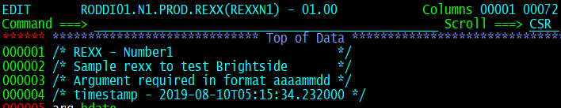

Test still has the new version that needs to be modified after figuring out what the problem was in production. In the real world, more and different tests should be added to the Pipeline in order to avoid wrong installations in PROD. It should have failed in the TEST tests.

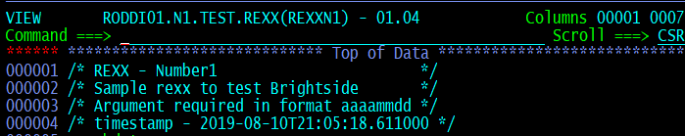

1. Edit the ‘**start.rex**’ script, and comment again the lines we have used to cheat in this practice and let the script behave correctly:



* Practice 3: Modify the program ‘REXXN1’. There is a request of modification of our program. There is another #1 list songs & artists from the US. Now we want out program to give us both #1 in UK and in the US. We will use the provided file ‘listUSMaster.txt’. To do so:

1. Edit